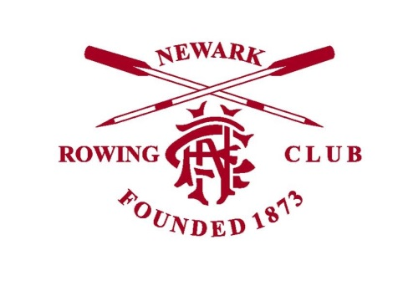

Junior Members on the Water at NRC

In line with British Rowing’s ‘Safeguarding & Protecting Children Policy’, the Club’s policy is very clear regarding supervision of water outings for Junior members:

- Junior members (under 18s) are not to be allowed out on the water without appropriate supervision.

- In very nearly all cases ‘appropriate supervision’ consists of an appropriately qualified adult member accompanying the outing in a coaching/safety launch.

- At the Coach’s and Captain’s discretion and following a risk assessment, it may occasionally be appropriate for older competent Juniors (over 16s only) to row in larger more stable boats containing adult members (8+ and 4x, 4+, 4- only) without an accompanying launch, but only in suitable river conditions and with appropriately qualified and competent adult members. Outings in small boats containing Juniors (1x, 2x, 2-) must always be accompanied by a safety launch.

- ‘Appropriate qualification’ for most instances will include a Criminal Records DBS check as a minimum. Please consult with the appropriate Coach, or the Club Captain or Welfare Officer for further advice, or if you are unclear regarding this.

Coaches and Members are expected to enforce this policy, there can be no exceptions.

Newark Rowing Club General Committee
April 2018

